**SYNOPSIS FOR**

**ANDRIOD NOTICE BOARD**

**ABSTRACT**

Abstract: The project is an electronic notice board that is controlled by an android device and displays message on it. Traditionally, there were notice boards where any information or notice had to be stick daily. This becomes tedious and requires daily maintenance. The project overcomes this problem by introducing an electronic display notice board interfaced to an android device through Bluetooth connectivity. The Bluetooth receives the message from the android device that is sent to an Arduino. Notice board is a primary thing in any institution/organization or public utility places like bus stations, railway stations and parks. But sticking various notices day-to-day is a difficult process. The Notice board is a common display for effective mode of providing information to the people, but this is not easy for updating the messages instantly. This project deals about an advanced Hi-Tech wireless Notice Board. This system is enhanced to display the latest information through an Android application of smart phones or tablet. Objective: The project aims at designing a LED based scrolling message display controlled from an android mobile phone. The proposed system makes use of Bluetooth technology to communicate from android phone to LED display board. This project is to develop an embedded system, which is used for instant information display using LED’s by using android Bluetooth module

**INTRODUCTION**

Abstract: The project is an electronic notice board that is controlled by an android device and displays message on it. Traditionally, there were notice boards where any information or notice had to be stick daily. This becomes tedious and requires daily maintenance. The project overcomes this problem by introducing an electronic display notice board interfaced to an android device through Bluetooth connectivity. The Bluetooth receives the message from the android device that is sent to an Arduino. Notice board is a primary thing in any institution/organization or public utility places like bus stations, railway stations and parks. But sticking various notices day-to-day is a difficult process. The Notice board is a common display for effective mode of providing information to the people, but this is not easy for updating the messages instantly. This project deals about an advanced Hi-Tech wireless Notice Board. This system is enhanced to display the latest information through an Android application of smart phones or tablet. Objective: The project aims at designing a LED based scrolling message display controlled from an android mobile phone. The proposed system makes use of Bluetooth technology to communicate from android phone to LED display board. This project is to develop an embedded system, which is used for instant information display using LED’s by using android Bluetooth module

**Circuit diagram**

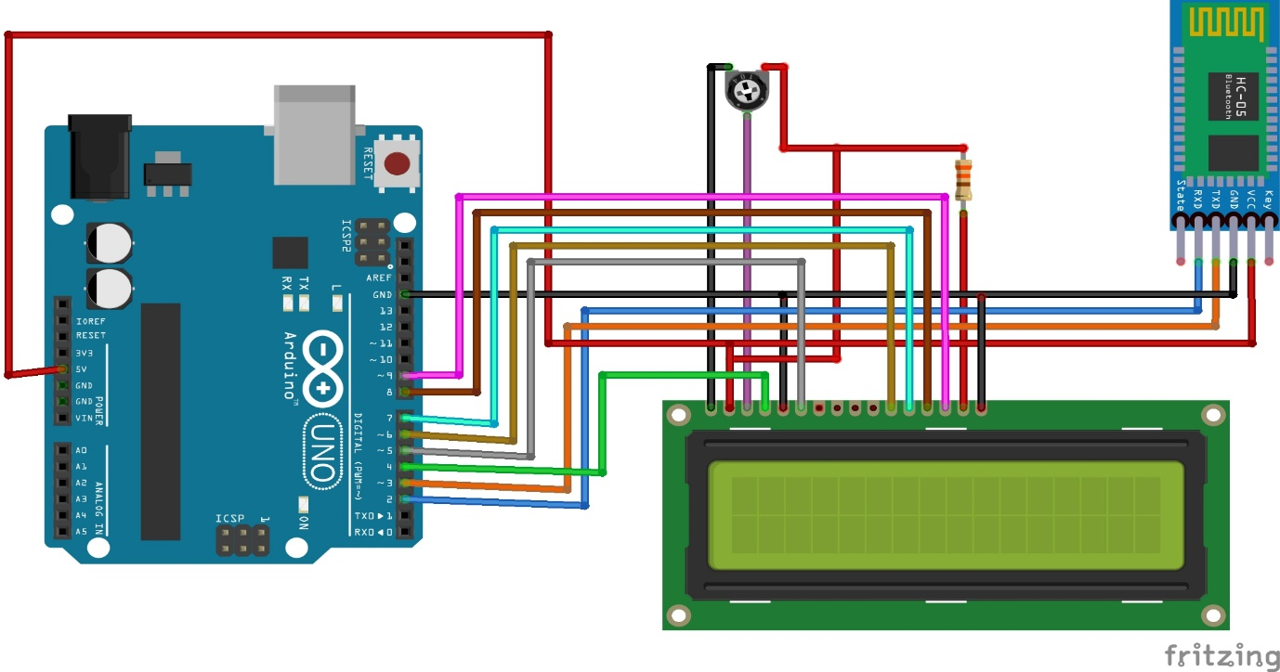

**Components required**

1. Single Turn Potentiometer- 10k ohms
2. Arduino UNO
3. Android device
4. HC-05 Bluetooth Module
5. Jumper wires (generic)
6. Alphanumeric LCD, 16 x 2
7. Arduino IDE app

**Steps to make this project:**

1. Gather all components like Arduino Uno, Bluetooth Module, LCD Display, Jumper wires etc.

2. Do connections of LCD Display.

" If you don't know How to do connections of LCD Display, then click on this link of How to Connect 16 x 2 LCD display"

https://electronicsisfun08.blogspot.com/2022/03/how-to-do-16-x-2-lcd-connections.html

3. After this connect Vcc and GND pins of Bluetooth Module.

4. Now upload the code in Arduino Uno.

5. Now connect Tx and Rx pins of Bluetooth Module with Arduino Uno.

6. Install the Android Application in Android Device.

Now, connect the HC-05 with application and send messages.

Your, wireless Digital Notice Board is ready.

**Android Application:-**

https://drive.google.com/file/d/1hYMHeInAhwSbxHwDcbOA1Chk4g_PZ-O6/view?usp=sharing

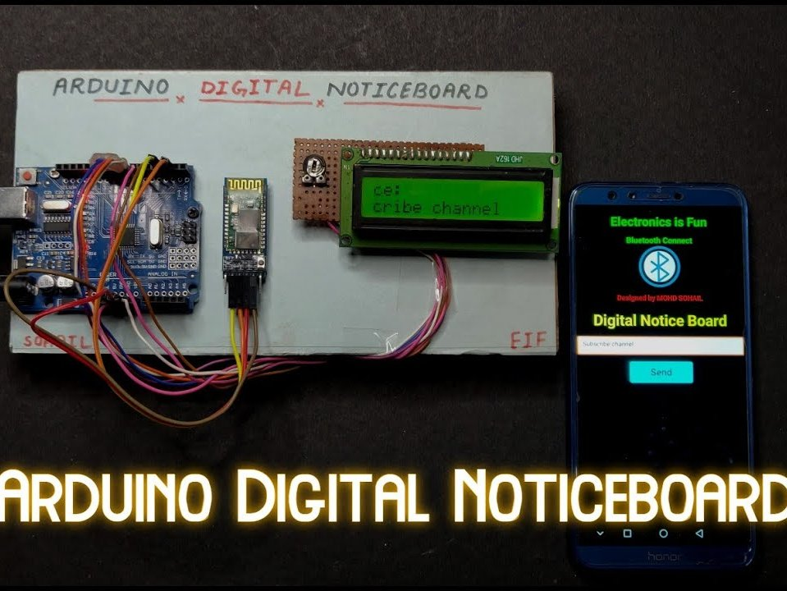

**GOVERNMENT OF KARNATAKA   
DEPARTMENT OF TECHNICAL EDUCATION  
BOARD OF TECHNICAL EDUCATION,BANGLORE**



**Vidya Vikas Education Trust, Polytechnic  
Allanahalli, Mysore Bannur Road, Mysore – 570028**

**FIVTH SEMESTER DIPLOMA ELECTRONICS AND COMMUNICATION 2023-24**

**GROUP ACTIVITY-** ANDRIOD NOTICE BOARD

**SUBMITTED BY:-**

* KEERTHY H.K
* SAGAR .P
* SUBHASH KM